We are going to use on-premise sql database but same ideas apply for onpremise oracle database based on this your 1step bit different .

Step 1 (Correct Working Version): Run This Script in SSMS
Open SQL Server Management Studio and execute this entire script: database.sql

Step 1.1 : Verify Database Created Successfully
Run:
SELECT * FROM Customers;
SELECT * FROM Stores;
SELECT * FROM CustomerSegments;
SELECT * FROM CustomerSegmentMapping;
SELECT * FROM CustomerContacts;

Yes — once you have:
- installed SQL Server locally
- created the database
- loaded the data
- verified the tables

Step 2: Make the local SQL Server reachable from Microsoft Fabric
We are going to use on-prem database, the next thing is to connect Fabric to your local machine using: On-premises Data Gateway
1. Install the On-premises Data Gateway on the same machine
Install it on the computer where SQL Server is running.
Download from Microsoft here:
Download On-premises Data Gateway

2. Sign in with your Fabric / Microsoft account
Use the same account you use for Fabric.
3. Register the gateway
Choose: Register a new gateway on this computer
Give it a name like: SQLBits-Fabric-Gateway
XXXX@XXXXX.onmicrosoft.com and Password

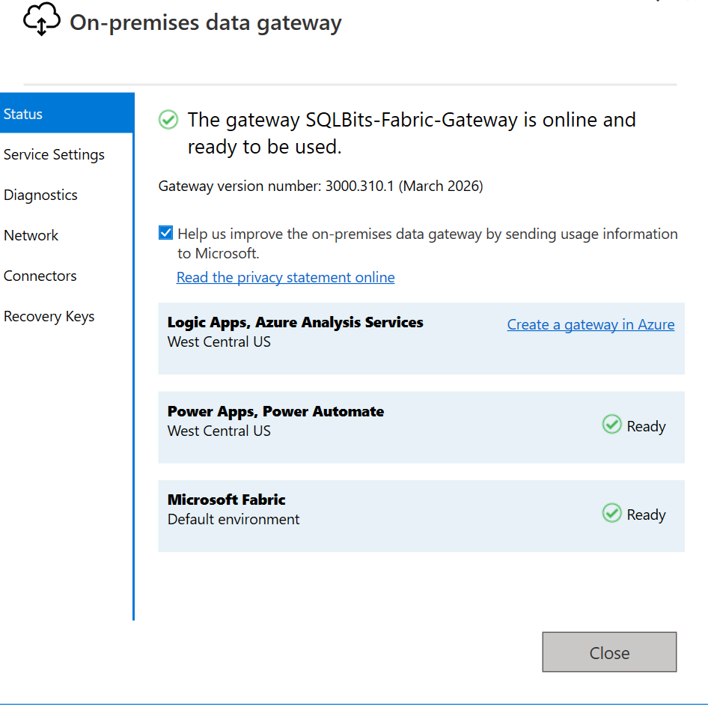

Step 4 — Add your local SQL Server as a Gateway Connection (Fabric portal)
After installing and registering the On-premises Data Gateway, you must create the SQL connection inside Microsoft Fabric (web portal).
Step 4.1 — Open Fabric settings
Go to: https://app.fabric.microsoft.com
Then click: ⚙ Settings (top-right corner)

Step 4.2 — Open gateway connection manager
Select: Manage connections and gateways
Step 4.3 — Select your gateway
Choose the gateway you registered earlier, for example: SQLBits-Fabric-Gateway
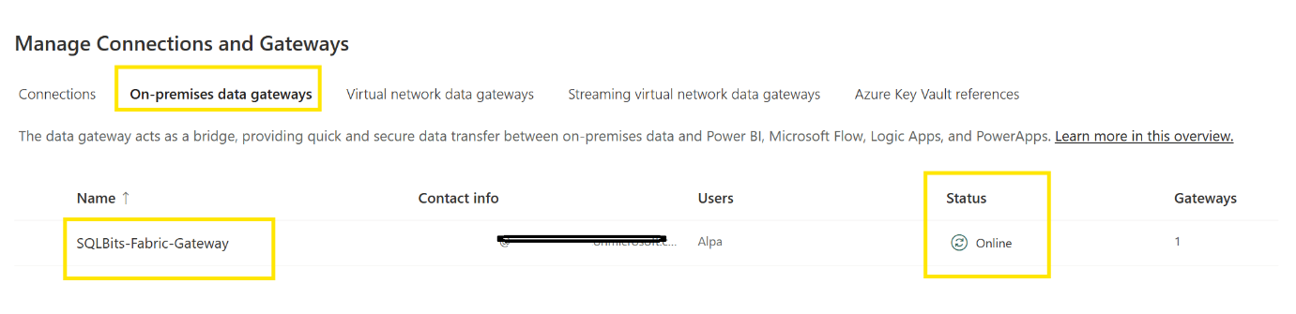

Step 4.4 — Create a new SQL Server connection
Click: + New connection
Fill in: Connection type - SQL Server
Server - localhost\SQLEXPRESS (or your actual verified local instance name)
Database - RetailERP
Authentication method : Windows/Basic Authentication
Then sign in when prompted.

Step 4.5 — Select gateway cluster
Choose: SQLBits-Fabric-Gateway
Step 4.6 — Set privacy level
Select: Organizational
Step 4.7 — Create connection
Click: Create
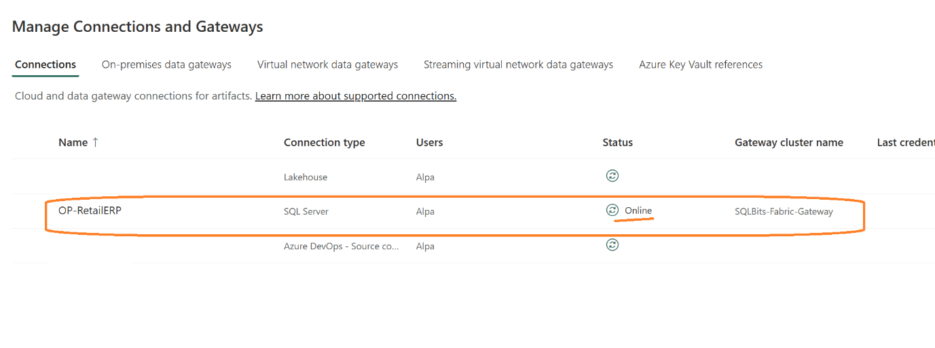

So far you have completed:
✔ Installed SQL Server locally
✔ Created RetailERP database
✔ Loaded source tables
✔ Installed gateway
✔ Registered gateway
✔ Created Fabric SQL connection through gateway
That completes source connectivity setup 🎯

Fabric → Gateway → Local SQL Server (RetailERP)

